**EXP 4: WEB FORM DEVELOPED USING SERVLET PROGRAM**

**AIM:**

To create a web formthat accepts a user's name and age, processes the data using JavaScript, and displays the submitted details with a stylish UI and animations.

**ALGORITHM:**

1. **Capture Submission**
   * Prevent default form submission
   * Get input values (Name, DOB, College)
2. **Validate Inputs**
   * Check for empty fields
   * Show errors if validation fails
3. **Process Data**
   * Format DOB (e.g., "January 1, 2000")
4. **Display Results**
   * Update result section with submitted data
   * Show hidden result div
5. **Smooth Scroll**
   * Auto-scroll to results for better UX

**PROGRAM:**

<!DOCTYPE html>

<html lang="en">

<head>

<meta charset="UTF-8">

<meta name="viewport" content="width=device-width, initial-scale=1.0">

<title>Student Information Form</title>

<style>

:root {

--primary-color: #4a6fa5;

--secondary-color: #166088;

--accent-color: #4fc3f7;

--background-color: #f5f7fa;

--text-color: #333;

--light-color: #fff;

--error-color: #e74c3c;

}

* {

box-sizing: border-box;

margin: 0;

padding: 0;

font-family: 'Segoe UI', Tahoma, Geneva, Verdana, sans-serif;

}

body {

background-color: var(--background-color);

color: var(--text-color);

line-height: 1.6;

padding: 20px;

}

.container {

max-width: 600px;

margin: 30px auto;

padding: 20px;

background: var(--light-color);

border-radius: 10px;

box-shadow: 0 5px 15px rgba(0, 0, 0, 0.1);

transition: all 0.3s ease;

}

.container:hover {

box-shadow: 0 10px 25px rgba(0, 0, 0, 0.15);

}

h1 {

text-align: center;

color: var(--primary-color);

margin-bottom: 20px;

font-weight: 600;

}

.form-group {

margin-bottom: 20px;

}

label {

display: block;

margin-bottom: 5px;

font-weight: 500;

color: var(--secondary-color);

}

input[type="text"],

input[type="date"] {

width: 100%;

padding: 12px;

border: 2px solid #ddd;

border-radius: 5px;

font-size: 16px;

transition: border 0.3s;

}

input[type="text"]:focus,

input[type="date"]:focus {

border-color: var(--accent-color);

outline: none;

box-shadow: 0 0 5px rgba(79, 195, 247, 0.5);

}

.btn {

display: inline-block;

background: var(--primary-color);

color: var(--light-color);

border: none;

padding: 12px 25px;

cursor: pointer;

border-radius: 5px;

font-size: 16px;

font-weight: 500;

transition: all 0.3s;

width: 100%;

text-transform: uppercase;

letter-spacing: 1px;

}

.btn:hover {

background: var(--secondary-color);

transform: translateY(-2px);

}

.btn:active {

transform: translateY(0);

}

#result {

margin-top: 30px;

padding: 20px;

background-color: #f8f9fa;

border-radius: 5px;

border-left: 5px solid var(--accent-color);

display: none;

}

#result h2 {

color: var(--secondary-color);

margin-bottom: 10px;

}

#result p {

margin-bottom: 8px;

}

.highlight {

font-weight: 600;

color: var(--primary-color);

}

.error {

color: var(--error-color);

font-size: 14px;

margin-top: 5px;

display: none;

}

.input-error {

border-color: var(--error-color) !important;

}

@media (max-width: 768px) {

.container {

padding: 15px;

}

}

</style>

</head>

<body>

<div class="container">

<h1>Student Information</h1>

<form id="studentForm">

<div class="form-group">

<label for="name">Full Name</label>

<input type="text" id="name" name="name" placeholder="Enter your full name" required>

<div id="nameError" class="error">Please enter your name</div>

</div>

<div class="form-group">

<label for="dob">Date of Birth</label>

<input type="date" id="dob" name="dob" required>

<div id="dobError" class="error">Please select your date of birth</div>

</div>

<div class="form-group">

<label for="college">College Name</label>

<input type="text" id="college" name="college" placeholder="Enter your college name" required>

<div id="collegeError" class="error">Please enter your college name</div>

</div>

<button type="submit" class="btn">Submit Information</button>

</form>

<div id="result">

<h2>Your Submitted Information</h2>

<p><span class="highlight">Name:</span> <span id="displayName"></span></p>

<p><span class="highlight">Date of Birth:</span> <span id="displayDob"></span></p>

<p><span class="highlight">College Name:</span> <span id="displayCollege"></span></p>

</div>

</div>

<script>

document.getElementById('studentForm').addEventListener('submit', function(e) {

e.preventDefault();

// Reset error states

document.getElementById('nameError').style.display = 'none';

document.getElementById('dobError').style.display = 'none';

document.getElementById('collegeError').style.display = 'none';

document.getElementById('name').classList.remove('input-error');

document.getElementById('dob').classList.remove('input-error');

document.getElementById('college').classList.remove('input-error');

// Get form values

const name = document.getElementById('name').value.trim();

const dob = document.getElementById('dob').value;

const college = document.getElementById('college').value.trim();

let isValid = true;

// Validate inputs

if (!name) {

document.getElementById('nameError').style.display = 'block';

document.getElementById('name').classList.add('input-error');

isValid = false;

}

if (!dob) {

document.getElementById('dobError').style.display = 'block';

document.getElementById('dob').classList.add('input-error');

isValid = false;

}

if (!college) {

document.getElementById('collegeError').style.display = 'block';

document.getElementById('college').classList.add('input-error');

isValid = false;

}

if (!isValid) {

return;

}

// Format date for display

const dobDate = new Date(dob);

const options = { year: 'numeric', month: 'long', day: 'numeric' };

const formattedDob = dobDate.toLocaleDateString('en-US', options);

// Display results

document.getElementById('displayName').textContent = name;

document.getElementById('displayDob').textContent = formattedDob;

document.getElementById('displayCollege').textContent = college;

// Show result section

document.getElementById('result').style.display = 'block';

// Scroll to result

document.getElementById('result').scrollIntoView({ behavior: 'smooth' });

});

</script>

</body>

</html>

**OUTPUT:**

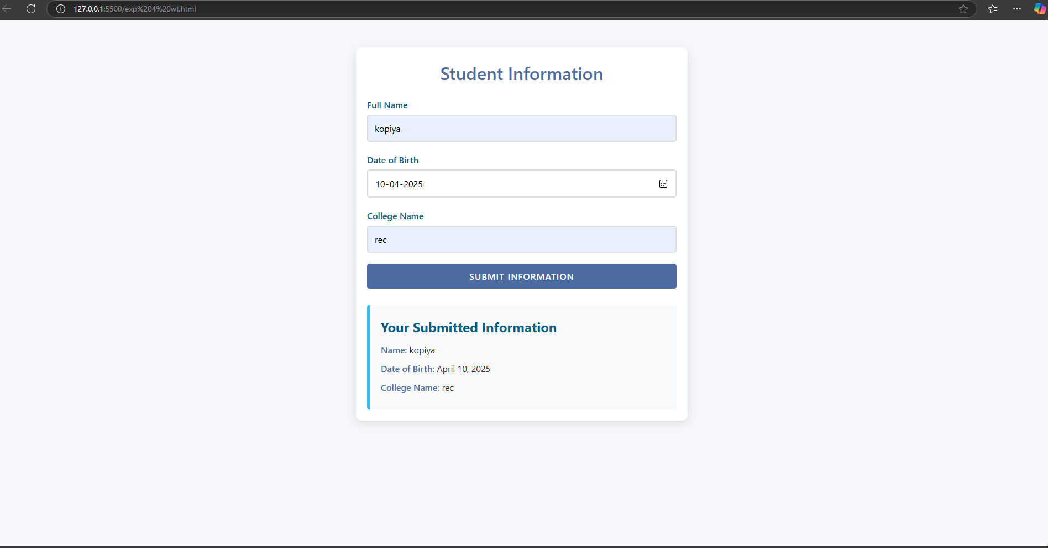

**RESULT:** The creation of web form using servlet program was executed successfully.